Evaluating User Experience and Visual Comfort in AI-Driven Human-Centric Lighting Systems: A Case Study in Office Environments
Evaluierung der Nutzererfahrung und des visuellen Komforts in KI-gestützten, human-zentrierten Beleuchtungssystemen: Eine Fallstudie in Büroarbeitsumgebungen
by
Danielle Scardini Lopes

Supervisors:
Prof. Dr. Matthias Hümmer
Stefan Traxinger

A thesis submitted in fulfillment of the requirements for the degree of Master of Engineering
Technische Hochschule Deggendorf
Healthy and Sustainable Buildings

April.xx.2026

Table of Contents
Table of Contents 2
1. Introduction 4
2.1 Background and Motivation 4
2.2 Research Questions 5
2.3 Overview of Research and Evaluation Approach 5
2.4 Summary of Key Findings and Contributions 6
2.5 Structure of the Thesis 6
2. Theoretical Background 7
2.1 Human-Centric Lighting and User Comfort 7
2.2 Visual and Non-Visual Effects of Light 7
2.3 Circadian Rhythm and Light Exposure 7
2.4 Smart Lighting Systems in Office Environments 7
2.5 Artificial Intelligence in Adaptive Building Systems 7
3. Methodology 7
3.1 Research Design 7
3.2 Research Setting and System Architecture 8
3.2.1 Physical Office Environment 8
3.2.2 Prototype Hardware Components and System Architecture 9
3.3 Control Strategies 10
3.3.1 Baseline Rule-Based Control 11
3.3.2 AI-Based Adaptive Control Model 11
3.4 Data Collection and Logging 12
3.4.1 Recorded Data Parameters 13
3.5 Evaluation Metrics and Analysis Methods 13
3.5.1 Operational Performance Indicators 14
3.5.2 Estimated Energy Performance 15
3.5.3 User Perception and Comfort Evaluation 16
3.5.4 Comparative Analysis Approach 16
3.6 Validity and Limitations 17

Introduction

2.1 Background and Motivation
Digital technologies are more integrated each day into building systems. Particularly in the office lighting field, they are transforming and multiplying the technical possibilities. The top-notch lighting equipment: modern LED luminaires, advanced sensors and controllers, make dynamic adjustments of light intensity and color temperature possible. High-end manufacturers create products capable of presence detection, daylight integration, and tunable-white control, theoretically supporting both energy efficiency and human-centric lighting strategies.
However, practical observation in real office environments exposes a different scenario. In many cases, luminaires remain switched on even when workstations are unoccupied, leading to unnecessary energy consumption. Even when presence sensors are integrated, the control is often not efficient. For example, luminaires may remain active continuously during occupied periods, regardless of sufficient daylight availability. This means that even though the lighting systems are technically functional, they are not being used in the most effective way.
This observation is particularly relevant in companies that position themselves as providers of high-quality interior and ceiling systems. When premium luminaires with advanced sensor technologies are not fully exploited, there is a gap between what technology can do and how it is actually used. Many luminaire manufacturers offer high-end products but do not provide integrated control systems as part of their standard portfolio. Instead, smart functionality is frequently delegated to external building management systems or not implemented at all.
At the same time, the market for sustainable and healthy buildings is expanding. Energy efficiency regulations, ESG targets, and growing awareness of occupant well-being increase the demand for adaptable and evidence-based lighting solutions. Human-centric lighting focuses not only on visual comfort but also on the physiological effects of light. However, in practice, implementation is often limited to tunable-white features without a structured evaluation of user experience or system performance.
Underused sensors, missing adaptive control strategies, and the absence of structured evaluation mechanisms indicate clear potential for improvement. In this context, artificial intelligence can be considered as a promising extension of existing control approaches. Unlike predefined rule-based systems, AI-driven models are capable of processing multiple input parameters simultaneously, identifying patterns in environmental and user-related data, and continuously adapting system behavior over time. Rather than relying on fixed thresholds, AI has the potential to enable more context-sensitive and self-optimizing lighting control.
Since advanced luminaires are already present in offices, the key question is whether artificial intelligence can improve efficiency and user experience without requiring a complete system redesign.

2.2 Research Questions
Based on the identified gap between technological capability and operational performance, this thesis addresses the following central research question:
Main Research Question:
To what extent can an AI-driven adaptive control approach improve the operational efficiency and user-centered performance of an existing office luminaire system under real working conditions?
To operationalize this question, the following sub-questions are formulated:
- How does the performance of the existing manual lighting operation compare to an AI-driven adaptive control approach in terms of runtime behavior, dimming profiles, and estimated energy consumption?
- Does the implementation of AI-based adaptive control influence user perception of lighting quality, comfort, and satisfaction?
- Can measurable improvements be achieved without modifying the existing hardware infrastructure

2.3 Overview of Research and Evaluation Approach
To address the formulated research questions, this thesis follows an applied experimental approach within a real office environment. The study is conducted in cooperation with an industry partner and is based on an existing DALI-based luminaire system installed in the company’s office space.
The research design consists of two main phases:
Phase 1 - Baseline Condition: During the baseline phase, the luminaire operates under its existing manual user-controlled configuration, reflecting typical office practice. Sensor data (occupancy and illuminance), as well as luminaire parameters such as dimming level, correlated color temperature, and runtime behavior, are recorded continuously. In parallel, user perception of lighting quality and comfort is assessed through structured questionnaires.
Phase 2 - AI-Driven Adaptive Control: In the second phase, an AI-based adaptive control model is implemented within the same hardware infrastructure. Based on contextual input parameters such as occupancy status, measured illuminance, and temporal variables, the system dynamically adjusts brightness and color temperature. The same operational indicators and user feedback instruments applied during the baseline phase are used to enable direct comparison.
The evaluation combines quantitative and qualitative components. Quantitative analysis focuses on operational indicators, including runtime behavior, dimming profiles, and estimated energy-related performance derived from usage patterns. Qualitative assessment addresses user perception, comfort, and overall satisfaction. By maintaining identical physical and hardware conditions across both phases, the study isolates the impact of the control strategy itself.
This design enables a structured assessment of whether AI-driven adaptive control can enhance operational efficiency and user-centered performance in an already installed office lighting context under real working conditions.

2.4 Summary of Key Findings and Contributions
XXXXXXXXXXXXX AFTER DATA ANALYSIS

2.5 Structure of the Thesis
This thesis is structured into six chapters.
Chapter 1 introduces the research context, outlines the motivation, formulates the research questions, and presents an overview of the research approach.
Chapter 2 provides the theoretical foundation of the study. It reviews relevant literature on office lighting systems, DALI-based control architectures, human-centric lighting concepts, and artificial intelligence applications in building systems. The chapter establishes the conceptual framework necessary to position the research within existing academic discourse.
Chapter 3 describes the research methodology. It explains the experimental design, system architecture, baseline and AI-driven control phases, data collection procedures, and the applied evaluation methods. The chapter also addresses methodological limitations and validity considerations.
Chapter 4 presents the empirical results of the study. Operational performance indicators, estimated energy-related metrics, and user feedback data are analyzed and compared between the baseline and AI-driven phases.
Chapter 5 discusses the findings in relation to the research questions and the theoretical framework. It interprets the results, examines practical implications for adaptive lighting systems, and reflects on methodological constraints.
Chapter 6 summarizes the key findings, outlines the main contributions of the study, and provides recommendations for future research and practical application.

2. Theoretical Background

2.1 Human-Centric Lighting and User Comfort

2.2 Visual and Non-Visual Effects of Light

2.3 Circadian Rhythm and Light Exposure

2.4 Smart Lighting Systems in Office Environments

2.5 Artificial Intelligence in Adaptive Building Systems

3. Methodology

3.1 Research Design
This study follows an applied experimental field research design conducted within a real office environment. The objective is to evaluate whether an AI-driven adaptive lighting control approach can improve operational efficiency and user-centered performance compared to existing manual lighting operation.
The research is structured as a two-phase comparative investigation. In Phase I (baseline condition), the luminaire operates under its normal manual user-controlled configuration. During this phase, operational data such as runtime behavior, dimming levels, correlated color temperature (CCT), occupancy status, and ambient illuminance are recorded continuously. User perception of lighting quality and comfort is assessed through structured questionnaires.
In Phase II (AI-driven condition), an adaptive control model is implemented within the same hardware infrastructure. The AI-based system processes contextual input parameters, including occupancy and illuminance measurements, and dynamically adjusts brightness and color temperature. The same operational indicators and user feedback instruments applied during the baseline phase are used in order to ensure comparability.
The study combines quantitative and qualitative evaluation methods. Quantitative analysis focuses on measurable operational performance indicators, such as luminaire runtime, dimming profiles, and estimated energy-related performance derived from usage patterns. Qualitative assessment addresses subjective aspects, including perceived lighting quality, visual comfort, and overall satisfaction.
By maintaining identical physical and hardware conditions across both phases, the research isolates the effect of the control strategy itself. The only variable that changes between phases is the decision-making mechanism governing luminaire behavior. This design allows a structured assessment of the potential added value of AI-based adaptive lighting control under real working conditions.

3.2 Research Setting and System Architecture

3.2.1 Physical Office Environment
The experimental investigation was conducted in an operational office environment of the cooperating industry partner. The selected workspace consists of a standard desk-based office setting used for computer-based tasks and administrative work. The environment represents typical daily working conditions rather than a controlled laboratory setup.
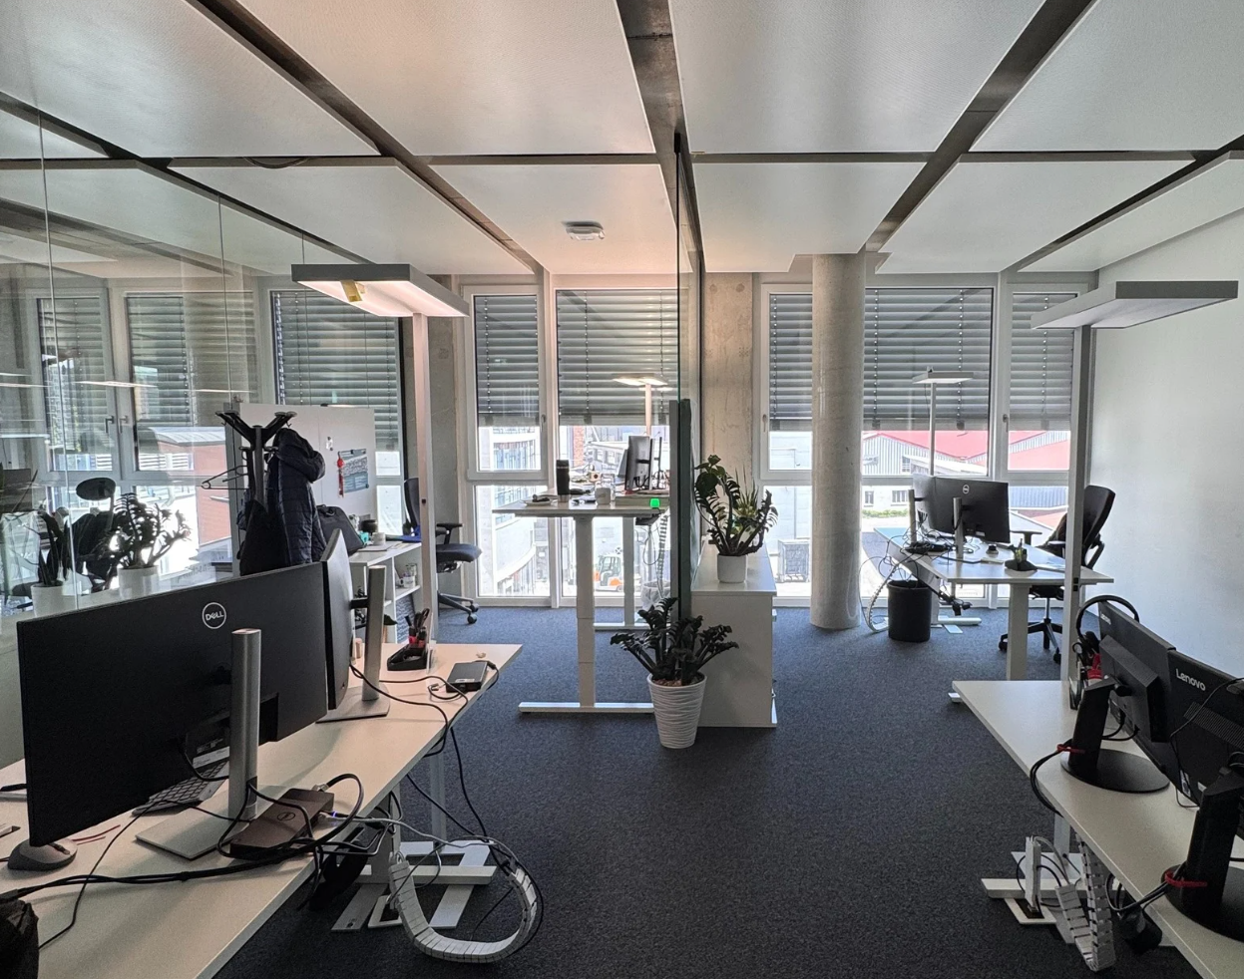
Figure XX – Research Office Environment (Author, 2026)
The workstation is located in proximity to façade windows, allowing natural daylight to enter the space. As a result, ambient lighting conditions vary throughout the day depending on time, weather conditions, and potential shading adjustments. This variability is relevant for evaluating adaptive lighting control strategies.
The investigated luminaire is positioned as a task-oriented floor lamp serving a single workstation. Although similar luminaires from the company’s product portfolio are installed in other offices, this study focuses on one representative DALI-based floor luminaire selected for experimental evaluation.
Conducting the study in a real working environment enables observation of authentic user behavior, including manual lighting adjustments and typical occupancy patterns. However, this field-based approach also implies reduced environmental control compared to laboratory conditions.

3.2.2 Prototype Hardware Components and System Architecture
To implement the adaptive control prototype, the following hardware components were used:
- DALI Floor Luminaire (DT8)
Provides digitally addressable brightness and color temperature control via DALI.
- Tridonic USB-DALI Interface
Serves as communication bridge between the control software (running on a computer) and the DALI bus. It translates USB-based commands into DALI telegrams and transmits them to the luminaire.
- ESP32 Dev Kit C (NodeMCU)
Acts as the embedded microcontroller responsible for sensor data acquisition and preliminary data processing. The ESP32 communicates sensor measurements to the control software.
- LD2410C 24 GHz Radar Presence Sensor
Provides occupancy detection using microwave radar technology. Compared to passive infrared (PIR) sensors, radar sensing enables more stable presence detection, including minor movements.
- BH1750 Digital Light Intensity Sensor (GY-302)
Measures ambient illuminance in lux. This value serves as an input parameter for the adaptive control logic.
The prototype follows a modular architecture consisting of three functional layers: sensing, decision-making, and actuation.
The sensing layer comprises the BH1750 illuminance sensor and the LD2410C presence sensor, both connected to the ESP32 microcontroller. The ESP32 collects sensor data and transmits them to the PC via USB serial communication at defined sampling intervals.
The decision-making layer is implemented on the PC. During the baseline phase, the luminaire operates under manual user control while sensor data and luminaire parameters are recorded. During the AI-driven phase, the control software processes contextual inputs such as occupancy status, measured illuminance, and temporal variables to determine appropriate dimming levels and CCT values.
The actuation layer consists of the Tridonic USB-DALI interface and the DALI-based luminaire. Control commands generated by the PC are transmitted via USB to the interface, converted into DALI telegrams, and forwarded to the luminaire via the DALI bus. Sensor data do not pass through the DALI interface; sensing and actuation remain functionally separated.
By modifying only the decision-making layer while maintaining identical luminaire hardware and communication infrastructure, the experimental setup isolates the effect of the control strategy on operational performance and user experience.
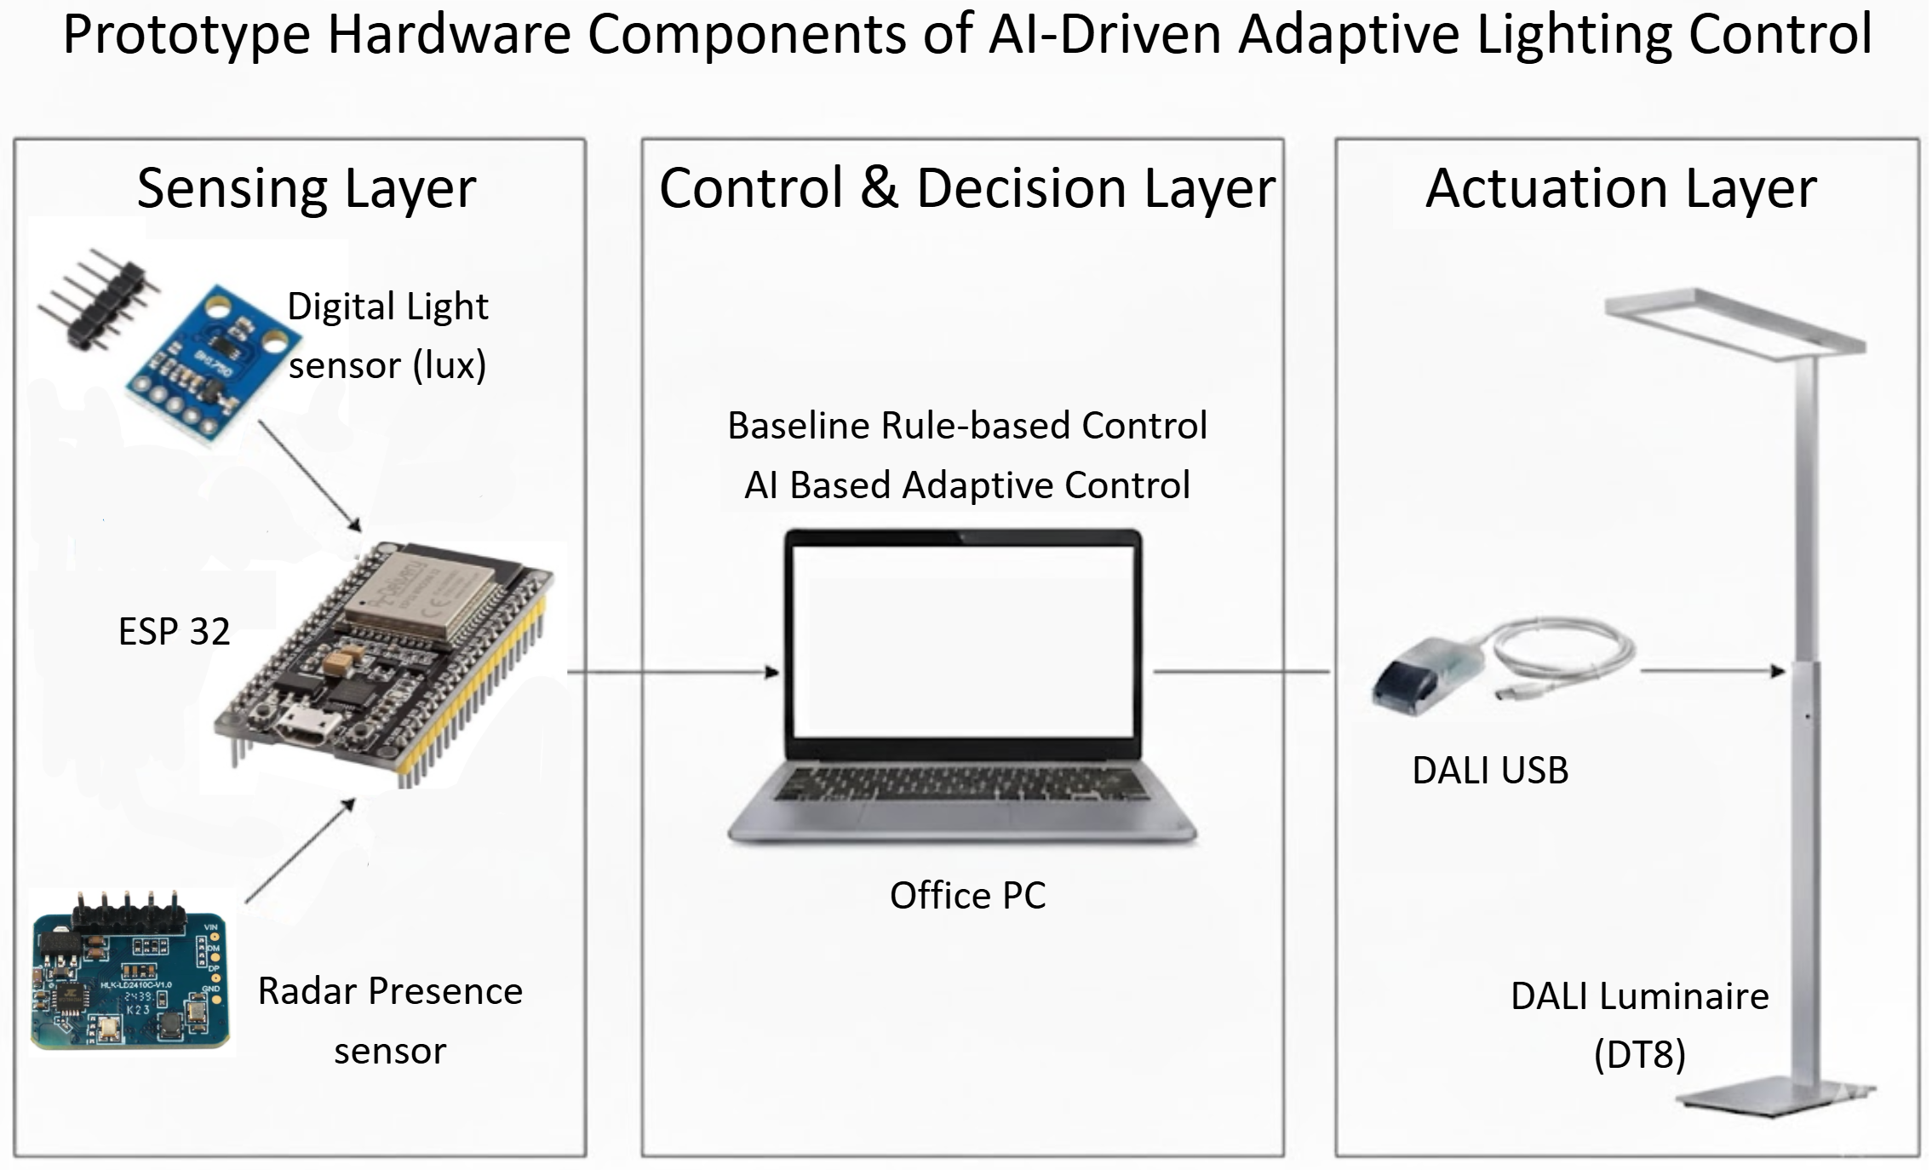
Figure XX – Prototype Hardware Components (Author, 2026)

3.3 Control Strategies
The experimental investigation is structured into two sequential phases: a baseline observation phase and an AI-driven adaptive control phase. Both phases are conducted under identical physical and hardware conditions. The only variable that differs between phases is the decision-making mechanism governing luminaire behavior.

3.3.1 Baseline Rule-Based Control
During Phase I, the luminaire operates under its standard manual user-controlled configuration. Users adjust brightness and correlated color temperature (CCT) according to individual preference using the existing control interface.
Throughout this phase, sensor data (occupancy and ambient illuminance) as well as luminaire parameters (dimming level, CCT, and runtime duration) are continuously recorded. The system does not influence luminaire behavior; it passively logs operational data for analysis.
This phase serves two purposes. First, it documents existing lighting usage behavior under real working conditions. Second, it provides a dataset that can be used to analyze inefficiencies, such as prolonged lighting during absence or mismatches between daylight availability and artificial lighting use.
User perception of lighting quality, visual comfort, and overall satisfaction is assessed through structured questionnaires administered during this phase.

3.3.2 AI-Based Adaptive Control Model
In Phase II, an AI-based adaptive control model replaces manual operation as the primary decision-making mechanism. The adaptive control approach follows a data-driven learning strategy based on operational data collected during the baseline phase. During Phase I, the system records environmental conditions, user adjustments of brightness and color temperature, and occupancy patterns. These observations serve as the training dataset for the adaptive control model. By analyzing relationships between contextual variables such as ambient illuminance, occupancy status, and time-related patterns, the model learns typical lighting preferences and operational behaviors. In the AI-driven phase, this learned relationship is used to predict appropriate lighting settings automatically.
The adaptive control system processes contextual input parameters, including occupancy status and measured ambient illuminance. These environmental variables are combined with temporal information to determine appropriate lighting settings. Based on these inputs, the system dynamically calculates suitable dimming levels and correlated color temperature (CCT) values for the luminaire.
To maintain stable and comfortable lighting conditions, the adaptive control system does not adjust lighting continuously. Although environmental sensor data are recorded at short intervals, lighting adjustments are evaluated at predefined control intervals. This approach prevents frequent visible lighting changes that could negatively affect user comfort.
The AI control algorithm evaluates environmental conditions every 5 minutes and determines whether adjustments to brightness or color temperature are necessary. To avoid unnecessary micro-adjustments caused by small sensor fluctuations, a minimum adjustment threshold is implemented. Lighting parameters are only modified when the calculated difference between the current state and the recommended lighting setting exceeds predefined limits.
Occupancy-based switching follows a separate logic. When no presence is detected by the sensor, the system waits for a defined delay period before switching off the luminaire. This delay prevents undesired switching behavior when users temporarily leave their workstation.
The timing configuration and adjustment thresholds used in the adaptive control system are summarized in Table XX.
Process | Interval / Condition | Description
Sensor Data Sampling | 5 seconds | Environmental data (occupancy and illuminance) are continuously recorded
AI Control Evaluation | 5 minutes | Control algorithm evaluates environmental conditions and determines potential lighting adjustments
Occupancy Absence Timeout | 1 minute | Luminaire switches off after sustained absence detection
Brightness Adjustment Threshold | > 5% change | Brightness adjustments occur only when the calculated change exceeds 5%
CCT Adjustment Threshold | > 100 K change | Color temperature adjustments occur only when the calculated difference exceeds 100 K
Table XX – Timing configuration of the adaptive lighting control system (Author, 2026)

3.4 Data Collection and Logging
Data collection was implemented to enable a direct comparison between the baseline and AI-driven phases. To ensure comparability, the same measurement procedures and logging structure were applied in both phases. Environmental conditions and luminaire operation parameters were recorded continuously and stored as time-series data for later analysis.
Sensor readings were recorded at fixed sampling intervals of 5 seconds, which provides sufficient temporal resolution to detect occupancy changes and variations in ambient daylight while keeping the data volume manageable.

3.4.1 Recorded Data Parameters
The following parameters were logged during the experiment:
Data Category | Parameter | Description | Data Source
Environmental Data | Occupancy Status | Indicates whether a person is present at the workstation | LD2410C Radar Presence Sensor
Environmental Data | Ambient Illuminance (lux) | Measures daylight and surrounding lighting conditions | BH1750 Light Sensor
Luminaire Operation | Dimming Level | Current brightness level applied to the luminaire | Control Software (PC)
Luminaire Operation | Correlated Color Temperature (CCT) | Selected color temperature of the luminaire | Control Software (PC)
Luminaire Operation | Activation Status | Indicates whether the luminaire is switched on or off | Control Software (PC)
Luminaire Operation | Runtime Duration | Total time the luminaire remains active | Control Software (PC)
Table XX – Recorded Data Parameters (Author, 2026)
Sensor data was transmitted from the ESP32 microcontroller to the PC via USB serial communication. Luminaire operation parameters were recorded directly within the PC-based control environment. All data were stored in structured CSV files with timestamps to enable synchronization between environmental conditions and luminaire behavior.
In addition to the operational data, user perception of lighting quality, visual comfort, and overall satisfaction was evaluated using structured questionnaires administered during both experimental phases (See Annex XXX). The questionnaire format remained identical to ensure comparability of responses.
Direct electrical power measurements were not conducted. Instead, energy-related performance was estimated based on luminaire runtime duration and the manufacturer’s nominal power values corresponding to the recorded dimming levels. This approach enables a comparative evaluation of relative energy performance between the baseline and AI-driven phases.

3.5 Evaluation Metrics and Analysis Methods
To evaluate the impact of the AI-based adaptive lighting control system, several evaluation metrics were defined based on recorded operational data and user feedback.
The analysis combines objective operational indicators derived from system measurements with subjective user feedback collected through questionnaires. This approach allows the study to evaluate both the technical performance of the lighting system and the perceived quality of the lighting environment from the user’s perspective.
Operational performance indicators are derived from recorded luminaire behavior and environmental sensor data. In addition, energy-related performance is estimated based on luminaire runtime and dimming levels. User perception of lighting quality and comfort is assessed through structured questionnaires administered during both experimental phases.
The following subsections describe the indicators and analysis methods used to compare the baseline and AI-driven control conditions.

3.5.1 Operational Performance Indicators
The following indicators are defined to enable a structured comparison between the baseline phase (manual control) and the AI-driven adaptive control phase.
Luminaire Runtime: Luminaire runtime represents the total duration during which the luminaire remains active during the observation period. Runtime is derived from the recorded activation status of the luminaire and aggregated over time. The total runtime is calculated separately for each experimental phase. Comparing runtime between phases allows identification of potential reductions in unnecessary lighting operation.
Lighting During Absence: Lighting during absence refers to periods in which the luminaire remains active despite no occupancy being detected by the presence sensor. These periods are identified by combining the luminaire activation status with the occupancy sensor data. The total duration of lighting during absence is calculated for both experimental phases. A reduction of this indicator in the AI-driven phase indicates improved responsiveness of the lighting system to occupancy conditions.
Dimming Behavior: Dimming behavior describes the brightness levels applied during luminaire operation. The dimming level recorded in the control system represents the relative output level of the luminaire. For both phases, the average dimming level and the distribution of dimming values over time are analyzed. This allows evaluation of how brightness levels are used under varying ambient illuminance conditions and whether the adaptive control strategy modifies brightness behavior compared to manual user operation.
Color Temperature Behavior: Color temperature behavior is evaluated by analyzing the variation of correlated color temperature (CCT) values during luminaire operation. The recorded CCT values are examined over time to identify differences in the use of warm and cool light settings between experimental phases. This indicator provides insight into how the adaptive control system adjusts lighting characteristics compared to manual user adjustments.

3.5.2 Estimated Energy Performance
Direct electrical power measurements were not conducted during the experiment. Instead, energy-related performance is estimated based on the recorded luminaire operation data and the nominal power specifications provided by the luminaire manufacturer.
The estimation method combines the recorded luminaire runtime with the applied dimming levels during operation. Since the dimming level represents the relative output of the luminaire, it can be used as an approximation of the proportion of nominal power consumed during a given time interval.
For each recorded time step, the estimated power consumption is calculated by multiplying the nominal luminaire power by the corresponding dimming level applied during that interval. The estimated energy consumption over the observation period is obtained by aggregating the calculated power values across all time intervals.
The general calculation principle can be expressed as:
$$E_{estimated}=∑(P_{nominal}×D_{i}×t_{i})$$
Where:
$E_{estimated}$represents the estimated energy consumption
$P_{nominal}$is the nominal power of the luminaire at full brightness
$D_{i}$is the dimming level at time interval $i$expressed as a relative value
$t_{i}$represents the duration of the corresponding time interval
Although this method does not provide exact electrical consumption values, it enables a consistent comparison of relative energy performance between the baseline and AI-driven experimental phases. Differences in estimated energy consumption can therefore be interpreted as the result of changes in luminaire runtime and brightness levels introduced by the adaptive control strategy.

3.5.3 User Perception and Comfort Evaluation
User perception of the lighting environment is evaluated through structured questionnaires administered during both experimental phases (see Annex XX). The questionnaire captures subjective assessments of lighting quality, visual comfort, perceived stability of lighting conditions, and overall user satisfaction at the workstation.
Participants evaluate each statement using a Likert-scale rating system. The same questionnaire structure is applied in both the baseline phase and the AI-driven control phase to ensure comparability of subjective responses. The questionnaire is administered twice during the experiment: once at the end of the baseline phase and once after completion of the AI-driven phase. An additional comparative question is included in the second phase to assess user preference between manual and adaptive lighting control.
For analysis, responses are aggregated using average scores for each evaluation category. These results enable comparison of perceived lighting quality and comfort between the two experimental phases.

3.5.4 Comparative Analysis Approach
The evaluation of the adaptive lighting control system is based on a comparative analysis between the two experimental phases: the baseline phase with manual user control and the AI-driven adaptive control phase. Since the same luminaire hardware, sensing infrastructure, and data logging procedures are maintained throughout the experiment, observed differences in system behavior can be attributed primarily to the change in control strategy.
The analysis combines the operational performance indicators, estimated energy performance, and user perception data described in the previous sections. For each indicator, the recorded values are aggregated over the observation period for both experimental phases. Key metrics such as total luminaire runtime, duration of lighting during absence, average dimming levels, and estimated energy consumption are calculated separately for each phase.
User questionnaire responses are summarized using average Likert-scale scores for each evaluation category. These values provide a structured representation of subjective user perception of the lighting environment under both control conditions.
The comparison between phases focuses on identifying relative differences in system behavior and user perception rather than establishing statistically generalizable results. The findings therefore provide an exploratory assessment of whether the AI-based adaptive control approach can improve operational efficiency and user-centered lighting performance under real office conditions.

3.6 Validity and Limitations
Although the experimental design enables a structured comparison between manual and AI-driven lighting control, several methodological limitations must be acknowledged.
First, the study is conducted using a prototype system architecture implemented within a real office environment. While the luminaire itself is part of the existing product portfolio of the industry partner, the sensing and control components were integrated specifically for the purpose of this research. As a result, the implemented system represents a prototypical configuration rather than a fully integrated commercial product.
Second, energy performance is estimated rather than directly measured. The analysis relies on luminaire runtime and nominal power specifications provided by the manufacturer. While this approach allows relative comparison between experimental phases, it does not capture potential variations in real electrical consumption caused by driver efficiency or system losses.
Third, the empirical investigation is conducted using a limited number of participants and a single luminaire installation within a real office setting. The resulting findings therefore provide insights into the behavior of the adaptive control system in this specific context but cannot be interpreted as statistically generalizable results for broader office environments.
Finally, user perception is evaluated through self-reported questionnaire responses, which may be influenced by individual preferences, expectations, and situational factors. While the use of identical questionnaires in both phases ensures comparability, subjective evaluations inherently contain variability that cannot be fully controlled.
Despite these limitations, the study provides valuable insights into the operational behavior of AI-driven adaptive lighting control under realistic office conditions. The findings contribute to understanding how existing luminaire systems may be enhanced through adaptive control strategies without requiring significant hardware modifications.

